Jack 15 — Sept. 24, 2022

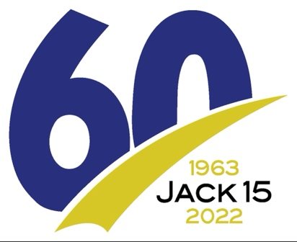

Important runner information

Packet pickup
• Friday, Sept. 23 — 4-7 p.m. at South Dakota Art Museum, 1036 Medary Ave. (basement hallway).
• Saturday, Sept. 24— 7 to 8:15 a.m. in White. Use the east entrance of the Deubrook High School gym (100 School Ave., two blocks west and one block south of starting line).

Friday evening’s program
This year marks the 60th running of the Jack 15, the oldest road race in the Midwest. Please join us as we honor this historic year with a free program at 7 p.m. in the South Dakota Art Museum auditorium. In addition to honoring the original 1963 runners, there will be a panel discussion by notable Jack 15 runners, including Bob Bartling, and a message from course record holder and inspirational speaker Dick Beardsley.

If you’re not running
The race is run on County Road 25, a paved road going south out of White; County Road 8, a dirt and paved road going west towards Medary Avenue (old Highway 77), which runs to the finish line.
There is virtually no shoulder on Road 25 and the course will be crowded at this point. Please consider waiting a few miles before cheering on your runner. If you’re transporting relay runners, please drop off the runner at Mile 3 and head to Road 8 (about 3 ½ miles). There is a gentle shoulder on the north side to park and cheer on your team.

Amenities
• Aid stations at miles 3.5, 6, 9, 12 and 14.5 with water and Powerade.
• Porta-potties by funeral home near the starting area and near mile 8. Restrooms and coffee available at the South Dakota Art Museum beginning at 9:30 a.m.)
• Bag drop at the school and near the start line. Taken to refreshments area at finish.
• Showers available at the SDSU Wellness Center, northeast of finish line. Runners must furnish own towels. Parking available in the north lot.

Race start
• 8:30 a.m. for individuals and relay teams.
Those in need of an early start should contact the race director.

Transportation
• Traffic will be controlled at the Highway 30 and Highway 14 intersections. All roads on the course remain open to traffic.
• An ROTC van will leave from the Campanile (finish line, 900 block of Medary Ave.) to the starting line at 7 and 7:45 a.m. A Boys & Girls Club bus will leave at 7:30 a.m.
• No transportation provided between relay exchange points.

Results and prizes:
• Individuals: In an 11 a.m. ceremony at the Campanile, we will honor the top three placers male and female, open and masters, as well as the overall male and female champions.
Certificates for the top three placers in age groups, male and female, will be awarded shortly after runners complete their race. Results will be posted on a Campanile door.
• Relay teams: Champions for male, female and coed in each relay division will receive their complimentary T-shirts shortly after they finish.
• Door prizes: Check the poster at the refreshment table to see if you won a door prize.
• Full results will be posted later in the weekend at PrairieStriders.net & raceentry.com.
• Photos: 2022 race photos taken by Brian Nelson.They can be found at: https://photos.app.goo.gl/GvbT4HZXfpvwtrke6
A clickable link is on the Jack 15 webpage at prairiestriders.net. Scroll far down the page.

Proceeds:
• Race proceeds help fund the Prairie Striders/Phil LaVallee Scholarship, which goes to a SDSU distance runner.

Course notes:
The course was recertified through USA Track & Field in 2021. Miles are marked with an American flag, a sign and pavement markings, which mark the exact mile point. At Miles 9 and 15, a bridge and the sidewalk prevent the sign and flag from being at the exact mile point.

Kids run:
10:45 a.m. Open to all children through age 12. Distances: .1 mile for 5 and younger; .25 mile for ages 6-8; .5 mile for ages 9-12. Register, start and finish at the Campanile. Free entry, free T-shirt. Organized by Miller Wellness Center, Jacob.Heidenreich@sdstate.edu

Race directors: Dave Graves, 651-4361; Brett Pettigrew, 999-0907.

